- Biography: Henry S. Ruizmeeden, born November 23,1970 in Phoenix, AZ. USMC Honorable Discharge. Never married and single with no children. Worked on CA farm in high school until the CA Farm closed in 1993. After CA Farm closed, Henry enlisted in the USMC to gain funds for a college education. In the USMC, Henry learned focus and attention to detail and subsequently excelled in the USMC & college. Henry joined the USMC Officer Candidate Program and planned to fly fighter jets for the USMC. After learning of the injustices inflicted by the USAF/DOD upon his mother, Henry decided a career in the military was not his future. Twenty-five-year career in the Home Mortgage Lending Industry. Currently employed by one of the three largest US National Banks.
- USMC Accomplishments: Twice Meritoriously Promoted. Honors Graduate at USMC Officer Candidate School. 100% Leadership Rating at USMC Officer Candidate School.
- Professional Accomplishments: Singlehandedly Designed and Implemented Mortgage Securities Basel Reserve Process, which increased earnings by $3.2 Billion USD for one of top three US National Banks.
- Education: Philosophy and Finance Majors at California Polytechnic State University, SLO CA and at Cuesta Community College, SLO, CA. Dean’s List. Several Academic Awards & Scholarships.
- Personal Disposition: Henry is introverted and prefers the company of a few close friends, who he is devoted to supporting.
- Notable Life Event: On 6/7/1989, Francisca Lopez-Ruiz gave Henry S. Ruizmeeden, who was 19 years old, a Power of Attorney to buy an AZ retirement home for her in Stanfield, AZ.
- Life Accomplishments: Diligently supported his mother, Francisca Lopez-Ruiz, aka Frankie, and his close friends throughout his life, which is precisely his life goal and ambition.
- Life Background and Interests: Enjoys reading Home Lending Regulations in his downtime. Hobbies include documentaries and reading. Hiking and weight training, for general health maintenance.
- Life Challenges: The loss of his beloved mother. Francisca Lopez-Ruiz and his cousin, who was his closest friend, Alejando “Larry” Ruiz, has left Henry with no close family.

Media Images on following page-

Henry Ruizmeeden Media-
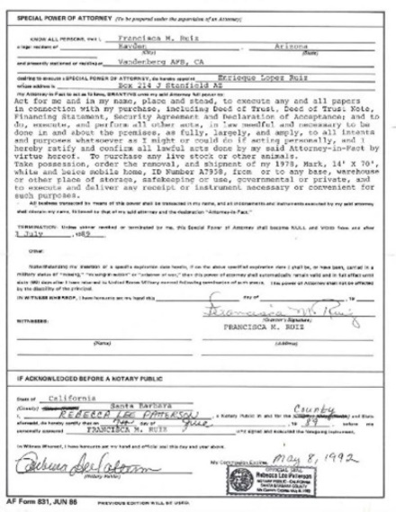
Francisca Lopez-Ruiz grants Henry a Power of Attorney in 1989 to build her an AZ retirement home and ranch, 6/7/1989
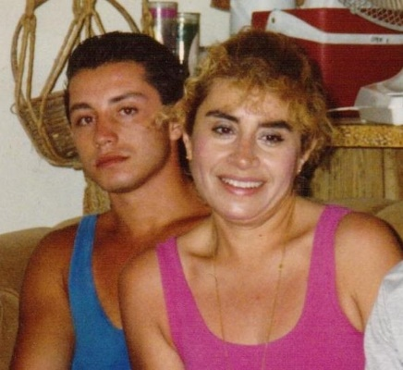
Henry and Frankie, circa 1989

Henry circa 2010

Henry Circa 2009
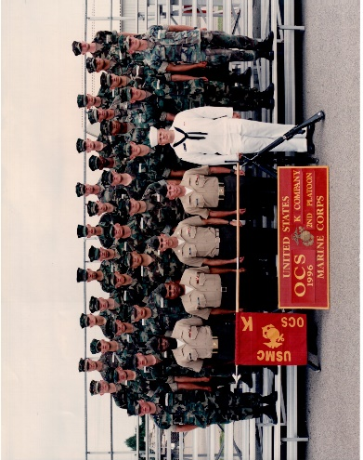
Henry USMC Officer Candidate School 1995
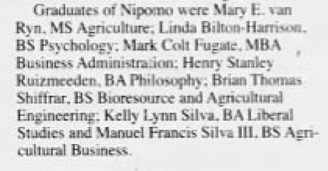
CalPoly Graduation Announcement for Henry Ruizmeeden on 1/14/2000 from Five Cities Times-Press-Recorder(except), whereas Henry withdrew from college in December 1999 and moved to AZ to support his mother, Frankie.
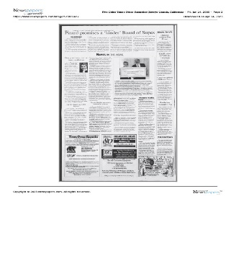
CalPoly Graduation Announcement for Henry Ruizmeeden on 1/14/2000 from Five Cities Times-Press-Recorder

.

